IHE Work Item Proposal (Detailed)

# Proposed Work Item: Point-of-care Medical Device Tracking (PMDT)

Proposal Editor: Ioana Singureanu (VHA), Denise Downing (AORN)

Work Item Editor: Ioana Singureanu

Date: November 7, 2016

Revised date: November 15th, 2016

Version: 1.0

Domain: Patient Care Coordination

**Summary**

This proposal is a combination of two brief proposals dealing with managing medical devices at the point-of-care:

* “Implantable Medical Device Registry Workflow Definition (IMDR-WD)” submitted by Denise Downing Informatics Nurse Specialist, Perioperative, AORN Syntegrity®
* “Point-of-care Medical Device Manager to improve patient safety, documentation clarity, and decision support”, submitted by Ioana Singureanu, BSEE, MSCS, FHL7, Standards Architect, Veterans Health Administration (VHA)

Both proposals included the requirement to record the identity of devices automatically (e.g. scanning), at the point of care, using its Unique Device Identifier (UDI) specified by manufacturers using of standard-based [supported formats](http://www.fda.gov/MedicalDevices/DeviceRegulationandGuidance/UniqueDeviceIdentification/UDIIssuingAgencies/default.htm).

UDIs on implantable medical device labels and packages and in certain cases, directly on the devices, will improve the quality of information for medical device adverse event reporting, to identity product quality issues more quickly, target recalls, and ultimately improve patient safety. These are not only US based concerns, but also international concerns as identified in the International Consortium for Orthopedic Registry (ICOR). ICOR is a US FDA sponsored initiative that represents 14 nations (i.e., England/Wales, Denmark, Portugal, New Zealand) to evaluate implant safety and effectiveness. This international consortium nor U.S. healthcare organizations collect surveillance data for implantable medical devices. When data has to be manipulated by an individual data quality becomes a factor. Manually transcribing data because it uses one standard and its source uses another it prone to human error. Incorrect data formatting or missing data can cause rejection of a registry submission or rework may need to occur. Patient safety can be jeopardized if incorrect data is transcribed and decisions made off of incorrect data.

# The Problem

This proposal is intended to close the loop on data acquisition at the point-of-care in support of reporting data about medical devices (e.g. implantable devices) and from medical devices (e.g. vital sign monitors, pulse oximeters, blood glucose monitors).

* Medical device measurements, settings, status, and alarms are transmitted to patient care system (e.g. ICU flowsheet) using existing standard transaction (e.g. IHE PCD-01 transactions based on HL7 Version 2. 7 ORU_R01) include only the device identification without patient identification information. This means that the receiving system (implementing Device Observation Consumer – DOC actor) is unable to match the device data with the correct patient. This leads to missing or erroneous data and could further lead to patient safety issues
* Implantable life-sustaining or life-supporting devices must be tracked to the patient and recorded along with procedure in the EHR to meet Meaningful Use 2015 certifications criteria. This information is necessary to address adverse events and recall notices specify to a device instance (based on device unique device identified using the FDA-specified UDI in the US). Currently we do not have a standard-based mechanism to capture the information consistently across care setting (e.g. hospital Operating Room, cardiology clinic, orthopedic surgery clinic).
* Medical device data may be persisted to the patient’s chart (if “validated/accepted” by clinicians), used for decision support, and exchange with other providers across the continuum of care (e.g. as referrals, transfer, discharge summary documents based on HL7 Consolidated CDA).

Implantable medical devices are essential for the treatment and management of a wide variety of medical conditions. These devices are costly and concerns about illegitimate (i.e., counterfeit, stolen) products being used for patient care has become a global issue. Post-market surveillance of implantable medical devices can be challenging due to the longevity of the patient and the medical device unless there is a reliable implant tracking method. In 2013, the United States Food and Drug Administration (FDA) issued a unique device identifier (UDI) system designed to identify and track implantable medical devices throughout their distribution and use in the United States. The EU will be developing and adopting similar legislation. The desire is to combine data from premarket approval with post-market settings to help address issues of cost and concerns about illegitimate products and to gain understanding of performance and clinical outcomes of implantable medical devices.

The manufacturer supplies a unique computer-readable identifier on the label of implantable medical devices to enable traceability of where the implantable medical device has been distributed. Unfortunately, it does not enable standardized data exchange from healthcare organizations inventory management systems (IMS) to an EHR and then to a national registry, where activities occur such as infection prevention or guideline development to protect patients from hospital acquired infections (HAIs). The inability to track a medical device from premarket through post-market surveillance systems for adverse event reporting, recalls, corrections, removals/revisions, continued evaluation on safety, effectiveness and reliability of device for intended use, due to the lack of standards available to electronically share the UDI data, makes post-market surveillance of implantable medical devices challenging.

Currently, healthcare organizations collect data on healthcare-associated infections (HAI) caused by certain medical devices (i.e., central venous catheters). Implantable medical device data is collected in a variety of ways, manually entered or partial look up in the electronic health record (EHR), manually entered in an EHR tab that doesn’t become part of the patients EHR, or manually on a study or registry log that is aggregated by a healthcare organization’s Quality Department or special study coordinator that is sent to the national registry. Inoperability of electronic data, manual data entry, and data manipulation lends itself to human error and inaccurate data capture leading to healthcare inefficiencies and patient safety errors.

Implantable medical devices enter healthcare organizations through a variety of methods. No matter the method used to requisition the implantable medical device, once it arrives at the healthcare organization supply chain, inventory control personnel scan the implantable medical device which adds it into the healthcare organization’s inventory and master item file. The UDI, which is embedded in one of the barcodes on the package, is not accepted by the IMS system. The IMS typically only accepts the global trade identification number (GTIN) from the scanned barcode. At the point of use the clinician scans the barcode on the implantable medical device package, if the healthcare organization has an automated identification and data capture (AIDC) technology. Or the clinician manually enters the UDI data into the EHR.

If the clinician has a scanner and finds the correctly formatted barcode, the scanner accepts the UDI. The barcode scanner and EHR system exchange the UDI data and the data becomes part of the patient’s EHR. The EHRs UDI data cannot be exchanged with the IMS for the healthcare organizations business processes because different data standards are being used on the device packaging that can’t be used by the IMS. By transforming the information that is stored in the different barcode formats into a standardized format, healthcare organization’s IMS and EHRs can become interoperable and standardized submission of that data can be exchanged with a national registry or payer organizations.

Implantable medical device failures, infections, or complications cost healthcare organizations and payer associations thousands of dollars. The benefits of this profile will improve patient safety, remove clinicians from manual data entry, foster accurate data capture, and provide an approach for implantable medical device collection to a national registry. This profile will produce the technical specifications for the exchange of implantable medical device data from the various healthcare information systems using the UDI barcode data to exchange with a national registry to track implantable medical device safety, effectiveness, and rates of infection.

# Use Cases

The main use case is to provide a standard-based approach to accomplish Patient-Device and Device-Operator Associations and Management using FHIR Procedure, FHIR Device using the UDI of physical device.

The main scenario uses FHIR Procedure and Device to associate a patient to one or more device(s) and operator/nurse/physician who configured or implanted the device. The device will be identified using the UDI scanned at the point of care along the patient id wristband, and the provider's badge.

* Create a FHIR Procedure specifying the patient, the device or devices involved, and the operator (i.e. perioperative nurse, respiratory therapist, etc.) or provider who configured the device, validated its configuration and initiated the procedure.
* If the device is implanted, a FHIR Device resource will associate the patient with the implanted device. The Patient Device List will be created by querying the EHR using a Device.search (by patient) operation.
* If the device is used monitor the patient or administer medication the procedure indicates duration, the associated medication order.

The scenario involves the use of system referred to as “Point-of-care Device Manager”. This system isHL7 FHIR client intended to track implantable devices, associate a patient to their monitoring devices, or help validate medication administration at the point of care using an infusion pump. This type of system uses FHIR resources to:

* start and end a monitoring session as a [Procedure](http://hl7-fhir.github.io/procedure.html) "in-progress" and updates the procedure at the end of the monitoring session (and set the status to "complete")
* create a [Device](http://hl7-fhir.github.io/device.html) resource corresponding to each device implanted during a surgical procedure and creates [Procedure](http://hl7-fhir.github.io/procedure.html) to document it.

**NOTE:** These interactions represent new capabilities to allow a Device Manager

to assign devices (implanted or used for treatment) to a specific patient.

Currently integrator use an ad-hoc HL7 V2 visit or appointment notification to start and stop a device monitoring session.

The following user stories illustrate the use case for three types devices using a common set of resources/transactions:

## Tracking Implantable Devices

**VHA Scenario:**

* SSgt. Sam Share, a **veteran**, receives a **consult** from Dr. Lister at a VA facility to treat his combat-related **condition**. It requires an implantable device to improve Sam’s health status.
* Dr. Lister, **VA physician**, prescribes an **implantable device or tissue** based on device type and other criteria (e.g. clinical size) and **orders** the **device** (based on device identifier (DI portion of UDI) the **procedure** (HCPCS)
  + The VA physician Looks up a suitable device using **prosthetic** list based on the FDA Global Unique Device Identifier Database (GUDID) or uses the pre-loaded “gold” Master Device Identifier file which is a local subset of device identifier records including SNOME CT device taxonomy codes. This local list allows enterprise application to look up devices based on:
    - By type, model, version, vendor, clinical size
* Ms. Martin, a **VA clerk** reviews the order before forwarding the information from the VA-approved distributor and obtains the device required for SSgt. Sam. Once the implantable medical device arrives at the medical center, its id is scanned and cross-referenced with the GUDID to ensure device legitimacy and recalls.
* A **procedure** is **scheduled** for SSgt. Sam, the device is implanted by Dr. Wilson and the UDI is scanned by the designated nurse into VistA. The UDI is associated with the patient and available to community providers in the “Patient Device List” of a CCD. If a recall is initiated, the manufacturer notifies VA to inform Sam and other patients using the same type of device in the affected production.

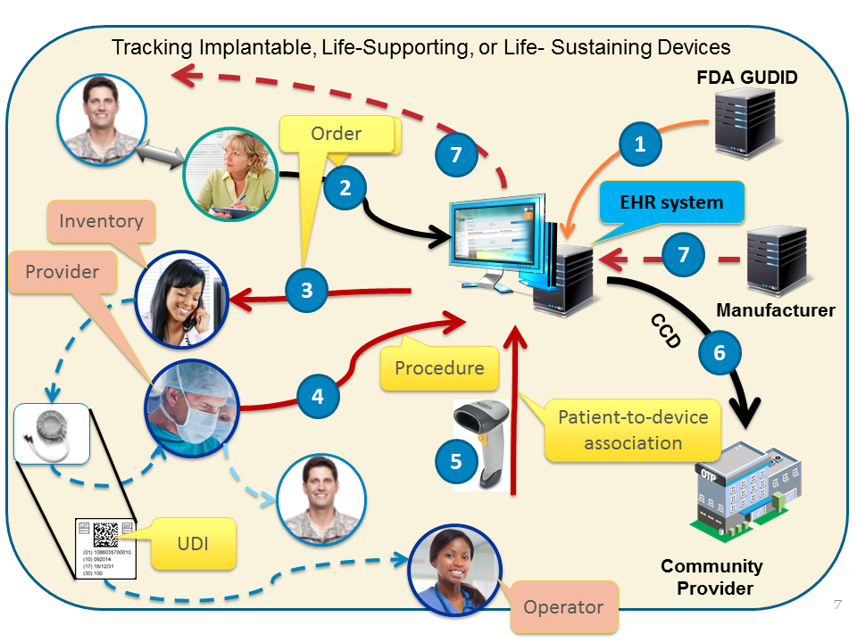

**AORN Scenario:**

Mr. Smith is a 65-year-old male who lives in Colorado and is very active, but his right knee arthritis has finally put a stop to his ability to hike. Mr. Smith goes to his primary care physician who refers him to Dr. Denver, an orthopedic surgeon. Dr. Denver performs an exam, sends Mr. Smith for some diagnostic studies, and determines a right total knee replacement is necessary. Mr. Smith is scheduled for a right total knee replacement, at St Castles Medical Center, using XYZ manufacturer’s knee replacement systems. Dr. Denver’s office schedules Mr. Smith’s total knee replacement with the operating room scheduling system.

St. Castles’ operating room has an Orthopedic/Spine Coordinator who reviews the surgical schedule to make sure the correct implantable medical devices are available for the scheduled procedures. XYZ manufacturer has a contract with St Castles Medical Center, but they do not stock the system that is needed for Mr. Smith. The Orthopedic Coordinator notifies the operating room (OR) materials manager (MM) to purchase the total knee components needed for Mr. Smith. The MM creates a purchase order (PO) using the medical center’s enterprise revenue program (ERP). The ERP system interfaces with the medical centers ORs materials (inventory) management information system (ORMMIS) for development of the ORs item master. The ORMMIS doesn’t exchange data within the medical center’s EHRs to capture specialty medical supplies and implantable medical devices used for patient care. If the UDI data was exchanged, the circulator nurse could then validate she has the correct implant for the patient by scanning and validating the barcode that came for the ORMMIS to the one she scanned on the package(s) - similar to identifying correct meds being administered.

Mr. Smith has his scheduled procedure and has XYZ implantable medical device implanted. The OR circulating nurse, using the medical centers’ EHR, manually documents the XYZ UDI barcode numbers on the packing because the scanner will not scan the barcodes on the medical device packaging used for Mr. Smith’s right total knee replacement procedure. Dr. Denver is part of a national orthopedic registry that is collecting data on total knee procedures. The Quality Department is given a list of all orthopedic procedures that Dr. Denver performed during the week and they begin to review each patient’s medical record for data elements that should be sent to the national registry.

## Vital Signs Monitoring and Charting

* SSgt. Sam Share (ret.) is admitted at the VA medical center and requires **continuous monitoring** of vital signs including oximetry. Dr. Lister orders monitoring for the next **24 hours**.
* Nurse Nightingale starts the monitoring session by **assigning** a standard-based vital sign monitor to Sam by **scanning the device label** and Sam’s **wrist band** (UDI🡨🡪PID) and her badge (PID🡨🡪EID). She uses the vendor-provided medical device manager or a VA-provided device gateway to record the devices associated with this procedure and patient.
* Once the patient-to-device association is completed any measurements, status information, reference ranges, etc. acquired by the device is exchanged with the flowchart system that persists the measurement in the VistA database using a common device integration adapter. **LOINC, SNOMED, UCUM** used to convey the measurements.
* Throughout the monitoring session, Ms. Nightingale validates the data entered by the integrated device into VistA. The validated results become part of Sam’s legal health record
* The CCD includes relevant/pertinent vital signs along with other treatment information

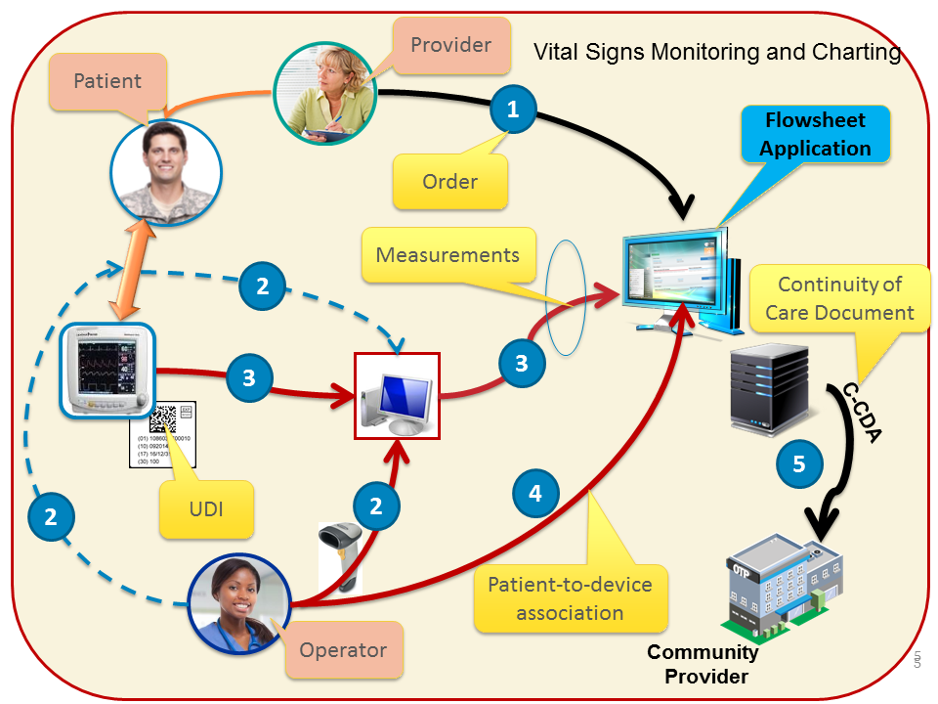

## Smart Device Programming and Tracking

* SSgt. Sam Share (ret.) is admitted at the VA medical center and requires medication administered intravenously using a “smart” pump. If used properly, “smart” pump features help prevents I.V. medication errors and reduce patient harm. Dr. Lister orders the drug, dose, route, time/frequency.
* The **patient**, **medication**, **dose**, **route**, **time/frequency** is sent to the infusion pump gateway.
* Nurse Nightingale starts the IV drug administration by assigning a “smart” pump to Sam by scanning the device UDI and Sam’s wrist band and her badge (**UDI**🡨🡪**PID 🡨🡪EID**) she establishes the patient, device, and operator of the device (EHR may verify it…)
* Once the patient-to-device association is completed, the pump gateway is able to associate the ordered medication with the pump assigned to Sam.
* Once the Ms. Nightingale validates the “5 rights” the device will send events and other administration information to the patient’s record. The medical device integration adapter used by the enterprise persists the information in the VistA database
* Throughout the IV session, Ms. Nightingale validates the data entered by the integrated device into VistA. The validated results become part of Sam’s legal health record. The EHR/VistA application to record documentation and validate reason and response to the medication

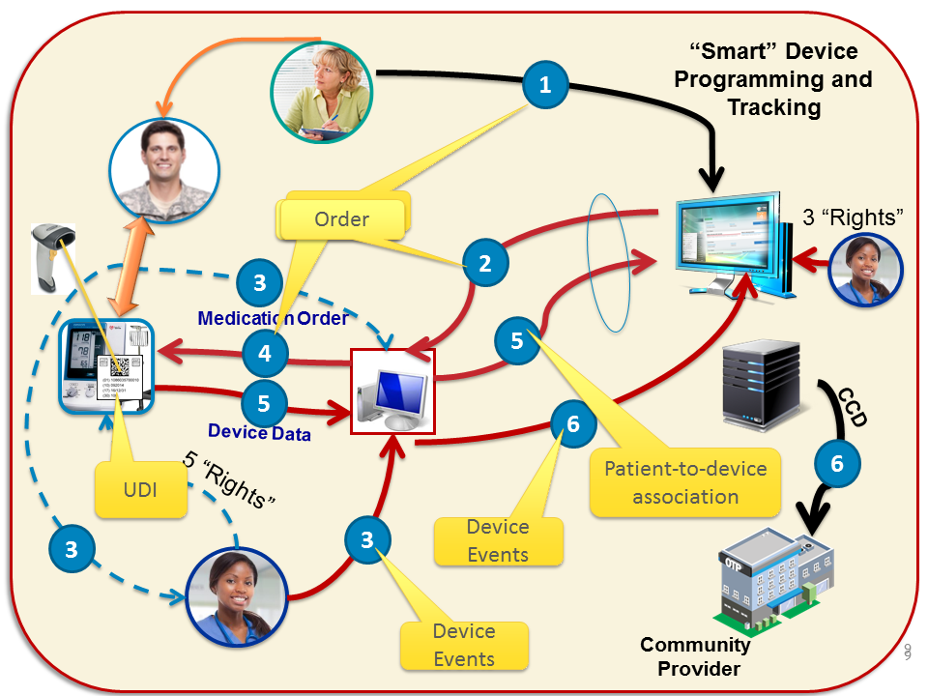

# Standards & Systems

[Harmonization Pattern for UDI](http://wiki.hl7.org/images/2/24/Harmonization_Pattern_for_Unique_Device_Identifiers_20141113.pdf) (referenced by the [ONC Standards Advisory for 2017 (Draft)](https://www.healthit.gov/standards-advisory/draft-2017)

[UDI Formats by FDA-Accredited issuing agency](http://www.fda.gov/MedicalDevices/DeviceRegulationandGuidance/UniqueDeviceIdentification/UDIIssuingAgencies/default.htm): GS1, Health Industry Business Communications Council (HIBCC), ICCBBA – the details of the format are explained in the [UDI formats by FDA-Accredited Issuing Agency Version 1.2](http://www.fda.gov/downloads/MedicalDevices/DeviceRegulationandGuidance/UniqueDeviceIdentification/GlobalUDIDatabaseGUDID/UCM396595.doc): March 9, 2016

Clinical terminology consistent with Meaningful Use 2015 (LOINC, SNOMED CT, RxNorm) based on the type of data to be represented. For PCD transactions, we will use the LOINC concepts provided by Regenstrief to represent IEEE 11073-10101 concepts.

# Technical Approach

The approach outlined here relies on the use of FHIR resources (i.e. RESTful services) to record information acquired at the point-of-care and add it to the set of data maintained by enterprise information system (e.g. EHR systems, IMS systems, flowsheets).

Unlike previous approaches that put the emphasis and responsibility on the enterprise to manage the point-of-care and ancillary systems, this integration profile adds new capabilities to the point-of-care systems (e.g. device managers) to enhance patient safety and effectiveness.

**New actors**

The new actors are effectively clients and servers implementing two FHIR resources: Device and Procedure:

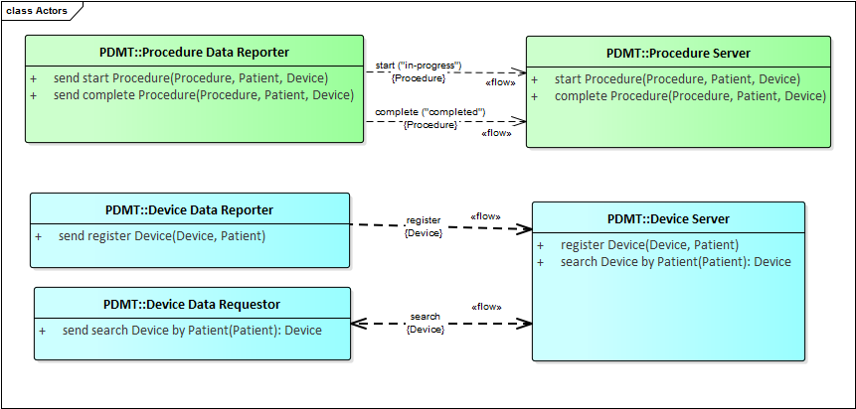

Figure 1: New Actors

* Procedure Data Reporter
  + It is implemented as FHIR Procedure resource client
  + Initiates the creation and update of a procedure for a vital sign monitoring session
  + It is used to identify the type procedure that implants a life-supporting or life-sustaining medical device or uses the device (e.g. pulse oximetry, vital sign monitoring, IV drug administration)
  + The reporter is implemented by a point-of-care system (e.g. Medical Device Manager)
* Procedure Server
  + Processes the requests and maintains the Procedure resources
  + It stores a record of the procedure used to implant a device or a procedure that uses a medical device (e.g. vital sign monitoring).
  + The procedure will provide unambiguous documentation of procedures that use a medical device or equipment at the point-of-care
* Device Data Reporter
  + Implemented as a FHIR Device resource client
  + The Device resource will reference the patient who received the implant
  + If the device is used to monitor a patient, the Device resource does not require a reference to the Patient
  + The Device resource includes the UDI of the device as human readable text representation of the scanned bar code
* Device Server
  + Processes the request to create and search Device resources
  + This actor could be implemented by Medical Device Registries for implantable devices
  + The type of queries (aka search operations) may be more extensive than the example shown in this proposal (i.e. “search by patient Id”).
* Device Data Requestor
  + Implemented as a FHIR Device resource client that implements the “search” operation and uses the parameters supported by the FHIR specification
  + This actor could be implemented by systems that compile an Implantable Device list for a patient consistent with the Meaningful Use 2015 EHR system certification requirements.

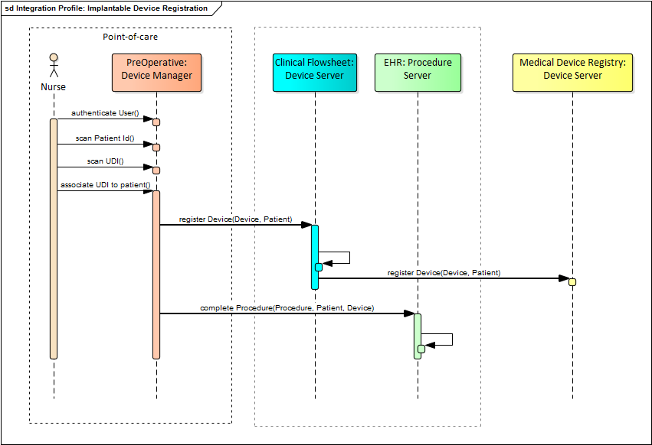

Figure 2: Sample workflow for Implantable Device Registration

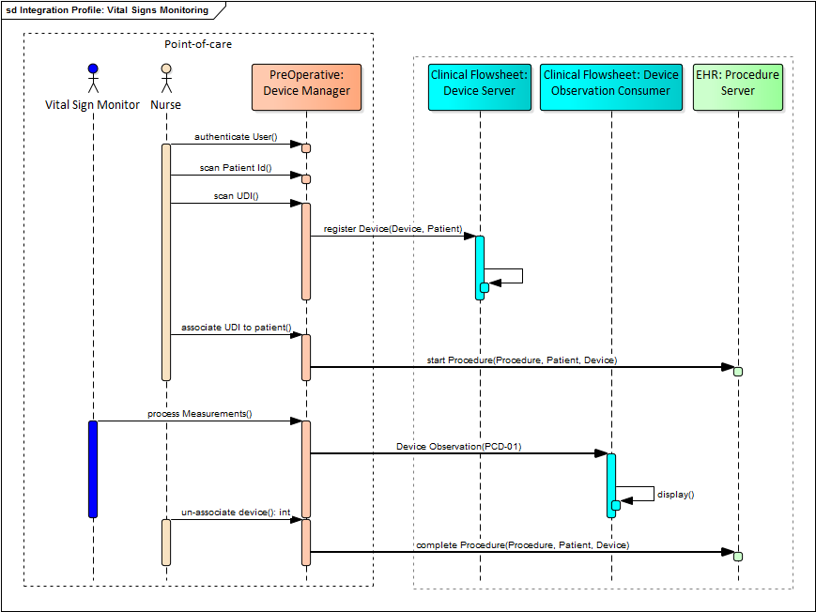

Figure 3: Sample workflow for vital signs monitoring - device and procedure tracking

**Existing actors**

IHE PCD De Device Observation Reporter and Device Observation

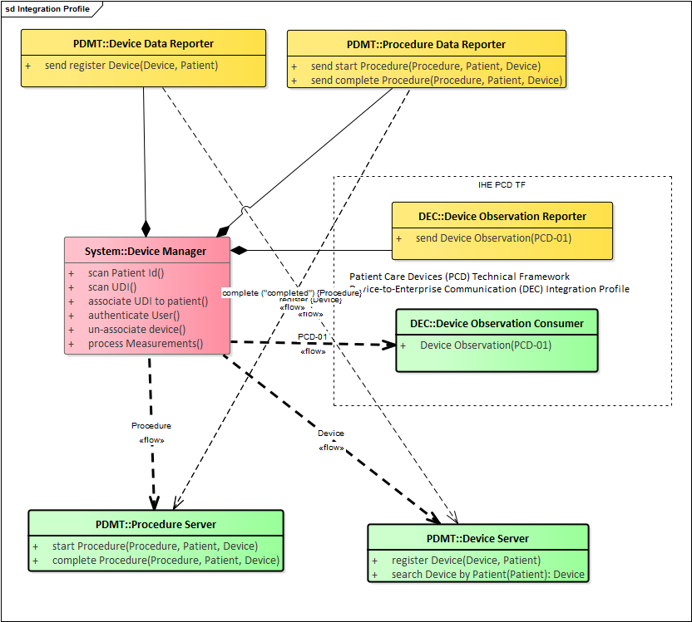

Figure 4:New and Existing Actors

**New transactions (standards used)**

The new transactions are based on FHIR STU2 resources. FHIR STU3 is still under development and, if the time allows, this specification may address both.



Figure 5: FHIR-based Transaction and reused IHE PCD-01 transaction.

Table : Sample Pulse Oximetry Procedure- shows potential requirements for a FHIR profile

|  |
| --- |
| <Procedure xmlns="http://hl7.org/fhir">  <id value="141194"/>  <meta>  <versionId value="1"/>  </meta>  <contained>  <Patient xmlns="http://hl7.org/fhir">  <id value="1"/>  <identifier>  <system value="urn:oid:2.16.840.1.113883.3.72.5.9.1"/>  <value value="patientId"/>  </identifier>  </Patient>  </contained>  <contained>  <Practitioner xmlns="http://hl7.org/fhir">  <id value="2"/>  <identifier>  <system value="urn:oid:2.16.840.1.113883.3.72.5.9.1"/>  <value value="operatorToken"/>  </identifier>  </Practitioner>  </contained>  <subject>  <reference value="#1"/>  </subject>  <status value="in-progress"/>  <code>  <coding>  <system value="http://snomed.info/sct"/>  <code value="252465000"/>  <display value="Pulse oximetry"/>  </coding>  <text value="Pulse Oximetry Procedure"/>  </code>  <reasonCode>  <text value="Point-of-care monitoring"/>  </reasonCode>  <performer>  <actor>  <reference value="#2"/>  </actor>  </performer>  <performedPeriod>  <start value="2016-09-18T11:31:43-04:00"/>  </performedPeriod>  <focalDevice>  <manipulated>  <reference value="http://fhirtest.uhn.ca/baseDstu3/Device/141193"/>  </manipulated>  </focalDevice> </Procedure> |

* create a [Device](http://hl7-fhir.github.io/device.html) resource corresponding to each device implanted during a surgical procedure and creates [Procedure](http://hl7-fhir.github.io/procedure.html) to document it.

Table : Device resource using UDI - "human readable" version of the scanned UDI:

|  |
| --- |
| <Device xmlns="http://hl7.org/fhir">  <id value="141193"/>  <meta>  <versionId value="1"/>  </meta>  <udiCarrier>  <system value="http://hl7.org/fhir/NamingSystem/fda-udi"/>  <value value="=/A9999XYZ100T0944=,000025=A99971312345600=>014032=}013032&amp;,1000000000000XYZ123"/>  </udiCarrier>  <type>  <coding>  <system value="http://hl7.org/fhir/identifier-type"/>  <code value="UDI"/>  <display value="UDI"/>  </coding>  </type> </Device> |

**Impact on existing integration profiles**

This specification is localized for use in the US, therefore the device unique identifier used in the PCD-01 transactions and any terminology requirements will be adapted to apply in the context of US enterprises that employ Meaningful Use certified EHR system.

**New integration profiles needed**

This proposal recommends the creation of a new profile that would enable the industry to create standard-based Point-of-care Medical Device Managers and Medical Device Registries.

These systems would implement the actors specified in this supplement.

**Breakdown of tasks that need to be accomplished**

* Model the workflow and validate with subject matter experts to refined the actors and transaction outlined in this proposal
* Derive FHIR profiles that implement the data elements and terminology required to convey the transaction

# Risks

* FHIR STU3 will likely not be approved during 2017.

# Open Issues

None

# Effort Estimates

VHA and AORN resources will collaborate on the draft supplement/Integration Profile.